**Process to execute Python Script by SQL Server**

Enable Machine Learning Services (MLS) while installing/modifying SQL Server.

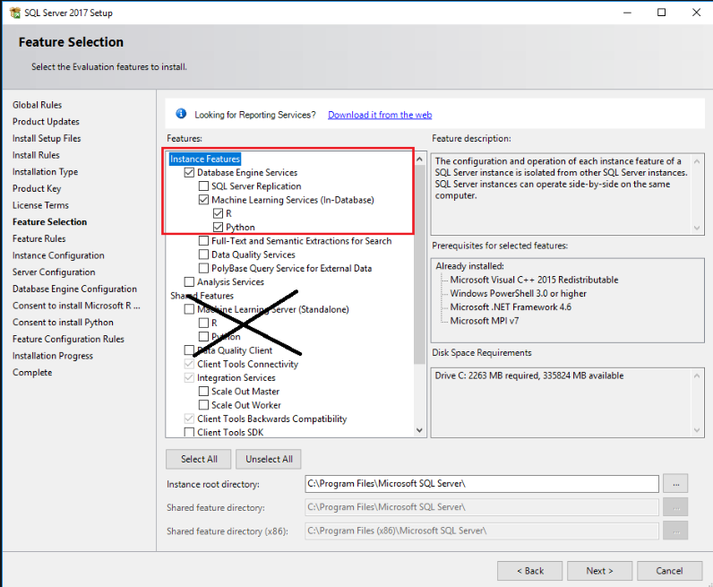

**Note:** Don't select the **Machine Learning Server (Standalone)** option under **Shared Features**. That option is intended for use on a separate computer.

Once Installed then need to restart SQL Server Launchpad (instance name) and SQL Server (instance name) both service

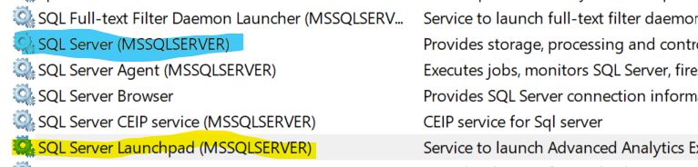

Once restart then enable external script execution feature as by below command.

-- To allow advanced options to be changed.

EXEC sp_configure 'show advanced options', 1

GO

-- To update the currently configured value for advanced options.

RECONFIGURE

GO

-- To enable the feature.

EXEC sp_configure 'external scripts enabled', 1

-- To update the currently configured value for this feature.

RECONFIGURE WITH OVERRIDE

GO

Now we are ablet to execute pyton inline script in the Query browser.

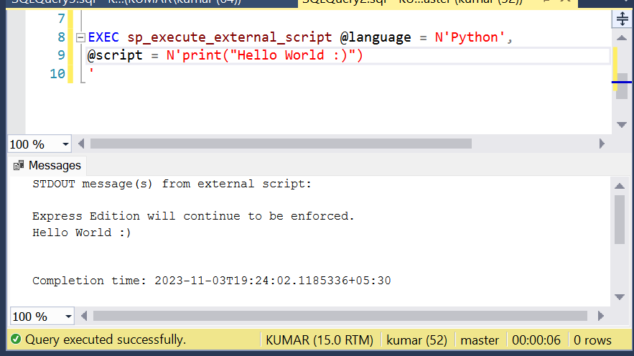

**How to run python script file (.py) from SQL Server.**

For this we need to create python script use EXECUTE PROCESS TASK such as SSIS to execute script file in SQL server.